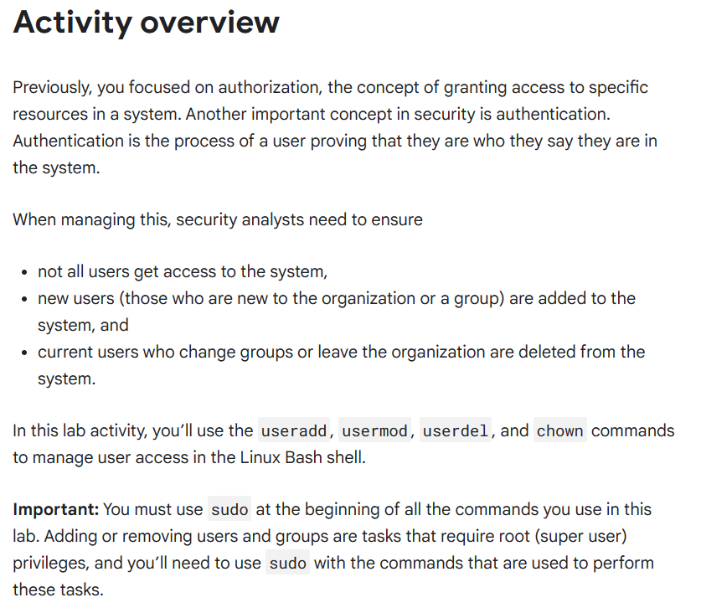

**Activity completed Using Linux bash shell**

**Explanation**

First, I created a new user named researcher9 on the system using the useradd command. Following that, I changed the primary group of researcher9 to research_team using the usermod -g command. This action associated researcher9 with the research_team group as their primary group.

Next, I used the chown command to change the ownership of the file /home/researcher2/projects/project_r.txt to researcher9. This command made researcher9 the new owner of the file, potentially altering access rights.

Then, I added researcher9 to the sales team group without changing their primary group, using the usermod -a -G command. This addition allowed researcher9 access to resources or permissions associated with both the research_team and sales_team.

Afterward, I attempted to delete the user researcher9 using the userdel command.

Finally, I executed the groupdel command to attempt deleting the group researcher9.